**Lab – CTF Lab Setup - SQL Injection to Shell**

**Overview**

This first lab will see how to easily create the lab environment for this CTF exercise using VirtualBox.

**Lab Requirements**

* Installation of VirtualBox
* Once virtual install of Kali Linux
* Once virtual install of the ISO image for From SQL Injection to Shell

You will need to download the ISO image for this CTF from Vulnhub.

[Download ISO image](https://www.vulnhub.com/entry/pentester-lab-from-sql-injection-to-shell,80/)

Once you have the ISO image downloaded and saved to a location on your machine, open VirtualBox. From the taskbar, click on **Machine,** and from the context menu, click on **New**.

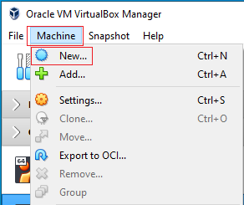

This starts the Create a Virtual Machine Wizard. On the first screen, fill in the following information.

* Name: CTF - From SQL Injection to Shell
* Machine folder: (Choose your save location)
* Type: Linux
* Version: Ubuntu (64-bit)

Accept the rest as defaults. Click **Create**.

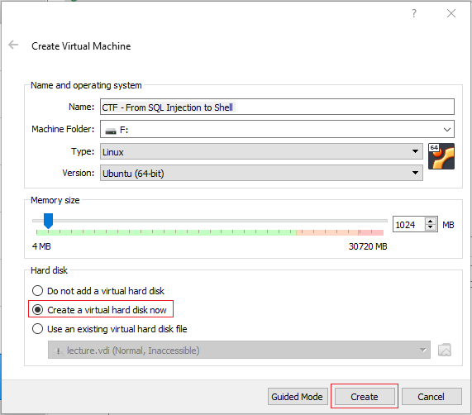

On the next page, accept the defaults. Click Create.

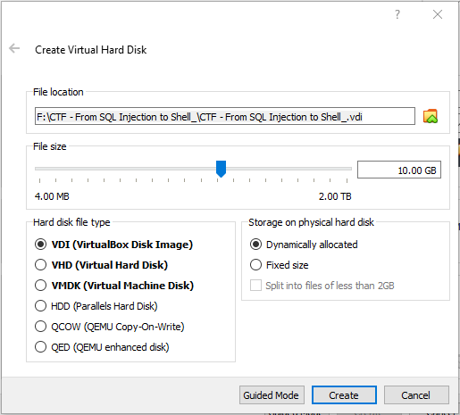

From the left windowpane in your VirtualBox manager, find the virtual machine you just created and x2 click it or select and use the green start button to launch.



On the Select a Startup Disk screen, click on the folder icon in the lower right corner.

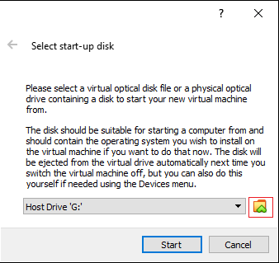

On the next screen, click the add button and browse to the save download location for saved ISO image.

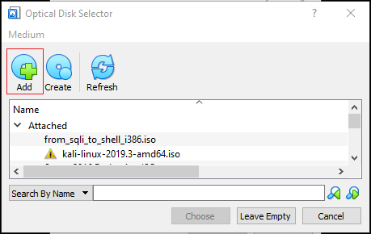

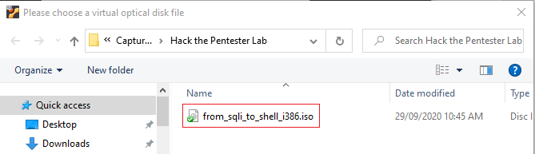

X2 click the ISO image and on the next page, click on Choose.

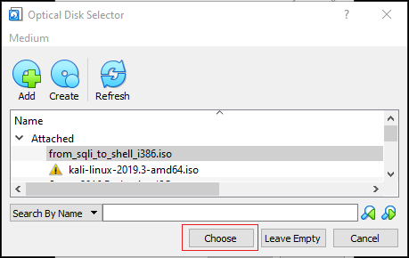

On this last screen, click start.

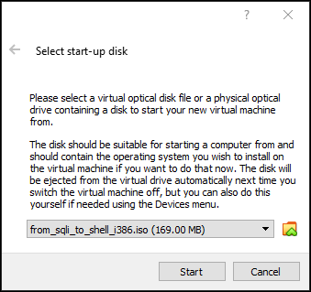

Allow the machine to load.

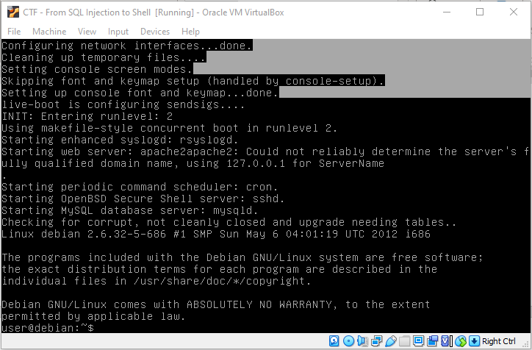

From the taskbar of your target, click on the Devices, go to network, and click on Network Settings.

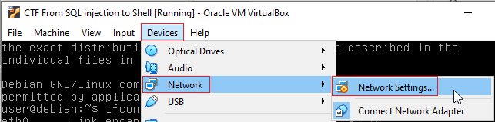

Configure your target to use Nat Network for its network type.

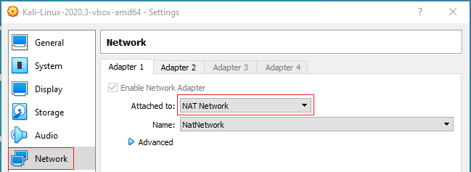

Configure your Kali’s network settings also to use Nat Network.

Maximize your target machine and at the prompt type ifconfig. This will show you the IP address assigned to your target machine. Your eth0 IP address is the one you will need this for this lab.

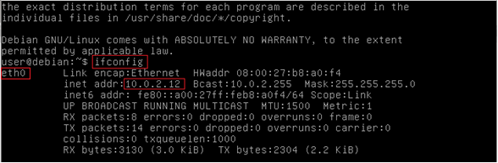

Bring up your Kali installation. Open a terminal and at the terminal prompt, type ifconfig.

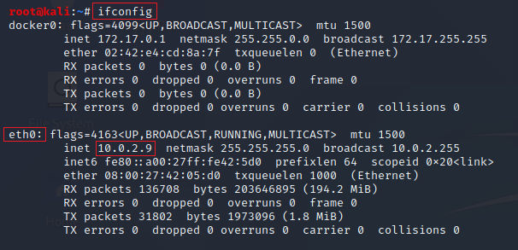

Your eth0 IP address is the one you will need for this lab. These are my IP addresses. Yours will differ.

You are now ready to process on with part 2 of this lab.

End of the lab!